**PC CONTROLLED SCROLLING MESSAGE DISPLAY FOR NOTICE BOARD**

**ABSTRACT**

This project is designed to develop a PC controlled scrolling message display for notice board. It can also be used to display latest information anywhere such as colleges, shops, railway stations and other places. The information is transmitted using PC. Traditionally notice board is all about sticking information, but sticking various notices day-to-day is a difficult process. A person is required separately to take care of this notice board. This system displays notices through a PC on notice boards.

This system can be implemented in many important places where latest information can be displayed. For example if implemented in colleges all information for students can be displayed. It is very convenient for students and college management to display any information. This system can also be implemented in railway stations and airports to display information regarding the train and flight timings. This system reduces the wastage of papers. The information is sent through a PC, which is interfaced to a 8051 family microcontroller through MAX232 interface IC. An external memory connected to the microcontroller stores the information. An LCD is connected to the microcontroller to display the message in a continuous scrolling manner.

**NOTE:**

**The project works only on operating systems having hyper terminal (E.g. Windows XP). The computer must have a RS232 serial port.**

**BLOCK DIAGRAM**

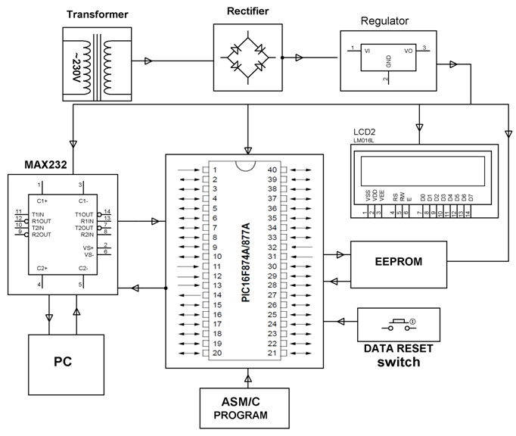

**SOFTWARE REQUIREMENTS**:

MPLAB, HI-TECH PICC Tool suite

Languages: Embedded C or Assembly.

**HARDWARE REQUIREMENTS:**

PIC series Microcontroller, Push buttons, Transformer, Voltage Regulator, LED, LCD, Resistors, Capacitor, Diode, MAX232, DB9 connector, EEPROM.